CS 255 System Design Document Template

This template lays out all the different sections that you need to complete for Project Two. Each section has guidance to prompt your thinking. You will need to continually reference the interview transcript as you work to make sure that you are addressing your client’s needs. There is no required length for the final document. Instead the goal is to complete each section based on what your client’s needs are. Remove this note when you are finished, and replace all bracketed text with the relevant information.

UML Diagrams

UML Use Case Diagram
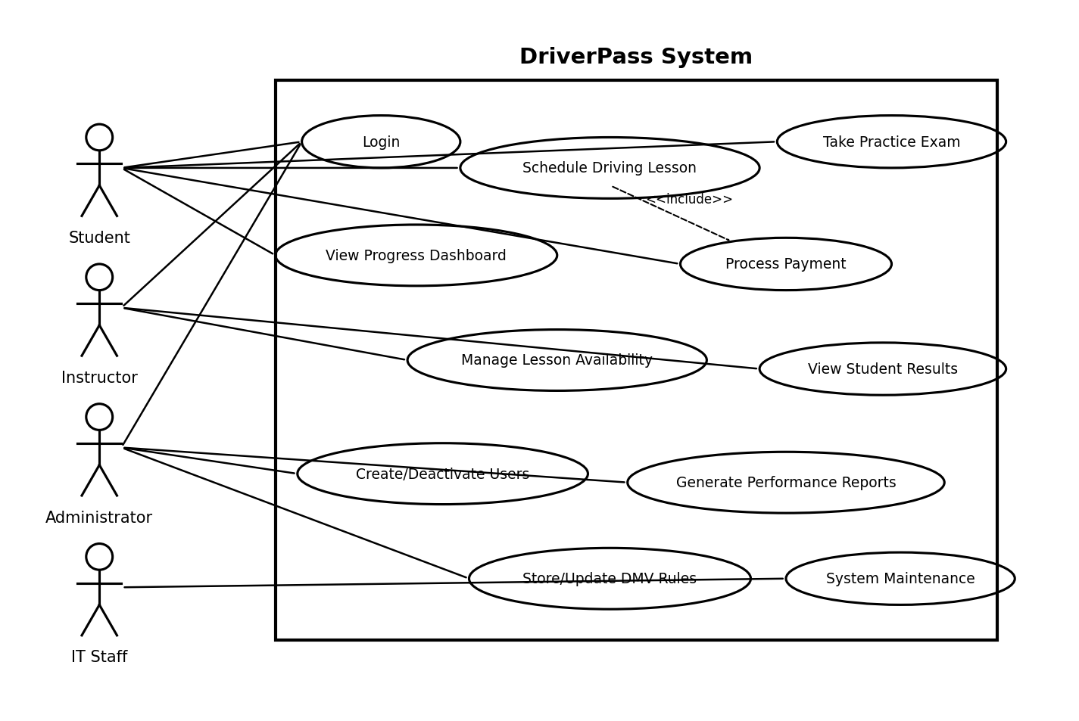

UML Activity Diagrams
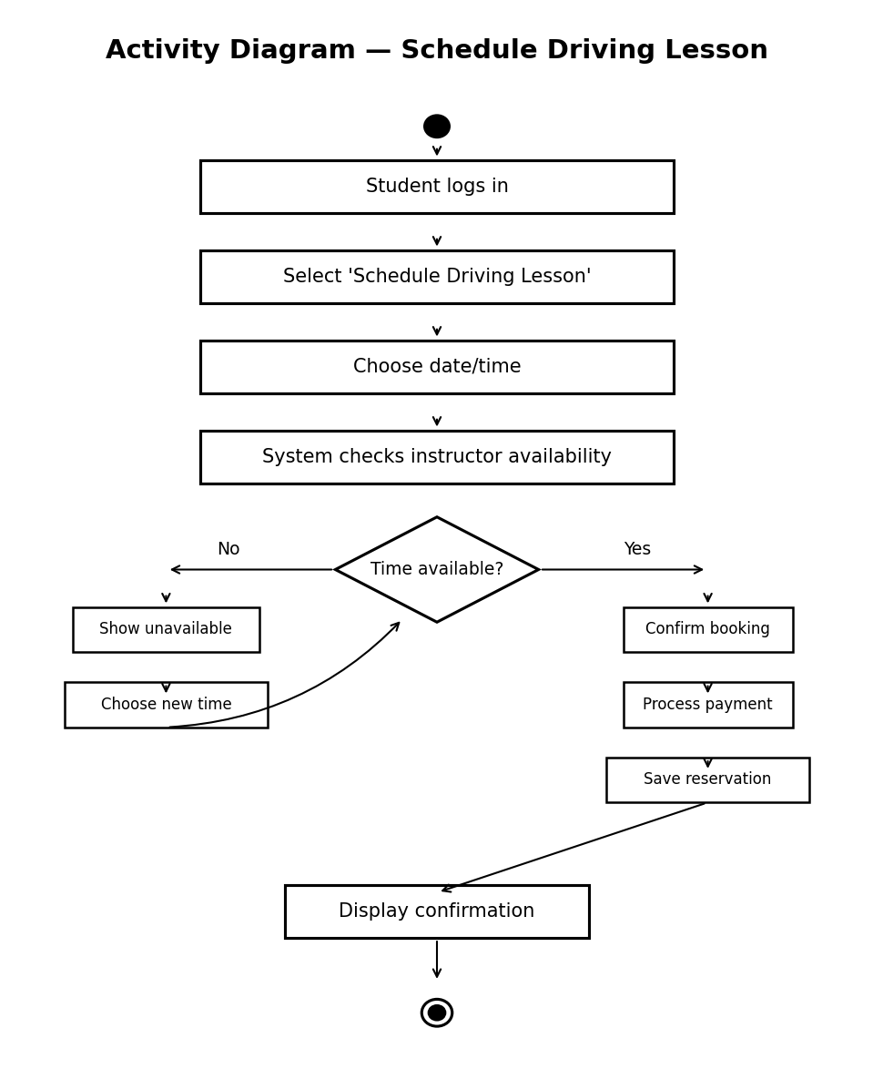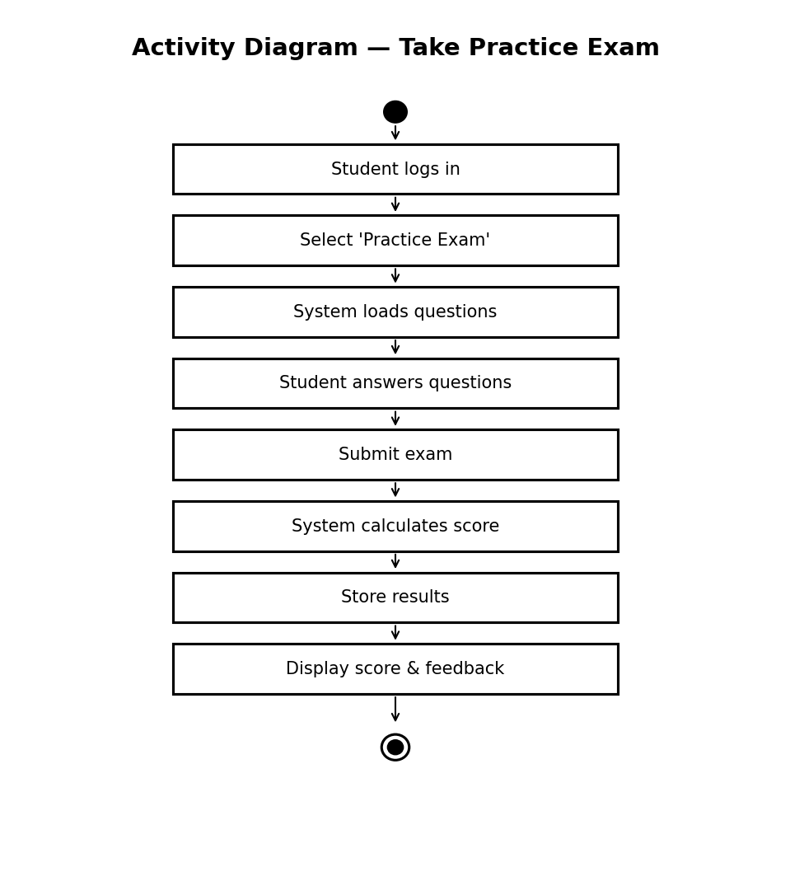

UML Sequence Diagram
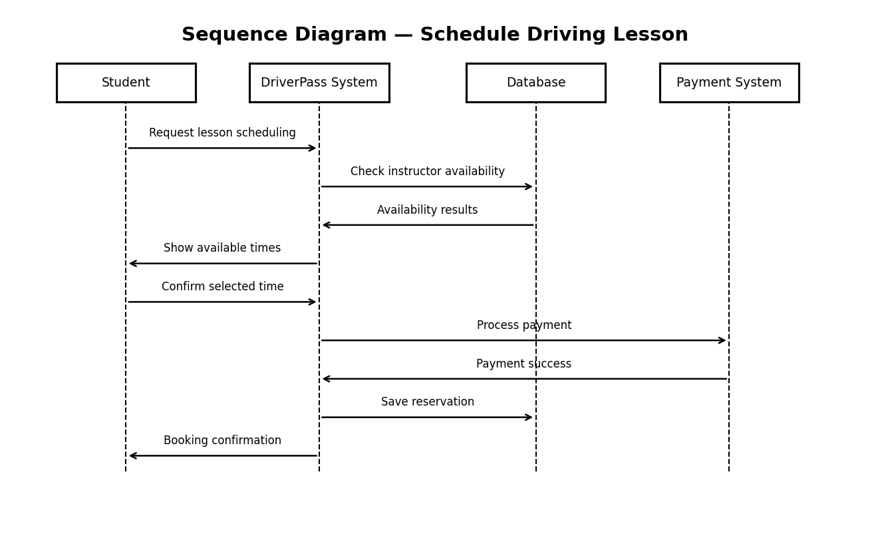

UML Class Diagram
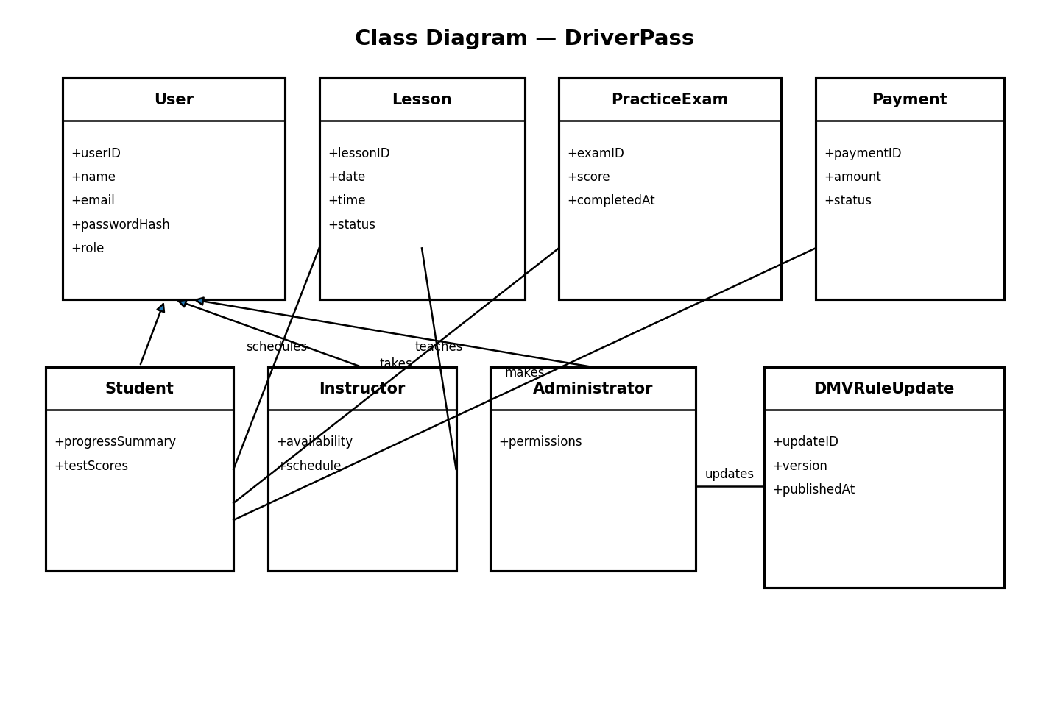

Technical Requirements
Hardware
• Cloud-hosted web server for the DriverPass application
• Client devices such as desktops, laptops, tablets, and smartphones
• Reliable internet connection for all users

Software
• Web-based application accessible through modern browsers
• Relational database system for storing users, lessons, exams, and payments
• Secure authentication system for user login and role management

Tools
• Lucidchart for UML diagrams
• Cloud hosting platform for deployment
• Payment processing service integration

Infrastructure
• Cloud hosting environment supporting scalability
• Encrypted data transmission (HTTPS)
• Secure database storage and backup system
• Role-based access control for students, instructors, administrators, and IT staff

